EXPERIMENT NO.8 (SAILOR BOAT DATABASE (DDL,DML,DQL, Subquery, Joins, Set operations)

AIM:

* Create sailors, boats, and reserves. (foreign key)
* Insert 5 values each table.
* Display all records.
* Find the names and ages of all sailors.
* Find all sailors with ratings above 8.
* Find sailors name with rating above 7 & age above 25.
* Display all the names & colours of the boats.
* Find all the boats with Red colours.
* Find the names of sailors' who have reserved boat number 103.
* Find the sids of sailors who have reserved blue boat
* Find the names of sailors' who have reserved Red boat.
* Find the colours of boats reserved by some name (provide any name in table).
* Find the names of the sailors who have reserved at least one boat.
* Find the names of the sailors who have reserved two different boats.
* Find the names of sailors who have reserved a Red or a Green boat. (union)
* Find the names of sailors who have reserved both a Red and a Green boat.
* Find the names of sailors who have reserved boat 103. (nested query)
* Find the names of sailors who have reserved red boat. (nq)
* Find the names of sailors who have not reserved red boat. (nq)
* Find the names of sailors who have reserved boat number 103. (exists)
* Find sailors whose rating is better than some sailors called name.
* Find sailors whose rating is better than every sailor' called name.
* Find the sailors with highest rating.
* Find the average age of all sailors.
* Find the average age of sailors with a rating of 10.
* Count the number of sailors.
* Count the number of different sailor ratings.
* Find the name and age of the oldest sailor.
* Find the names of the sailors who are older than the oldest sailor with a rating of 10.
* Find the age of youngest sailor for each rating level.
* Find the age of the youngest sailor who is eligible to vote (i.e., is at least 18 years old) for each rating level with at least two such sailors.
* For each red boat, find the number of reservations for this boat.
* Find all sailors name according to names.
* Find all sailors details according to rating.
* Find all sailors details according to rating (highest first) if ratings are same then according to age (youngest first).

SOLUTION:

**Components:**

Subquery: A subquery is also called an inner query or inner select, while the statement containing a subquery is also called an outer query or outer select.

Joins: A join is an SQL operation performed to establish a connection between two or more database tables based on matching columns, thereby creating a relationship between the tables.

Set operations: Set Operations in SQL eliminate duplicate tuples and can be applied only to the relations which are union compatible. Set Operations available in SQL are :

1. Set Union

2. Set Intersection

3. Set Difference

CREATE SCHEMA sailor_b;

CREATE TABLE boats(bid integer,bname varchar(30),color varchar(20));

CREATE TABLE sailors(sid integer,sname varchar(30),rating integer,age real);

CREATE TABLE reserves(sid integer,bid integer,DAY DATE);

desc boats;

desc sailors;

desc reserves;

Insert into sailors values(22,'Dustin',7,45.0);

Insert into sailors values(29,'Brutus',1,33.0);

Insert into sailors values(31,'Lubber',8,55.5);

Insert into sailors values(32,'Andy',8,25.5);

Insert into sailors values(58,'Rusty',10,35.0);

Select * from sailors;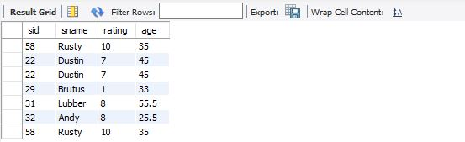

Insert into reserves values(22,101,10/10/98);

Insert into reserves values(22,102,10/10/98);

Insert into reserves values(31,102,11/10/98);

Insert into reserves values(64,101,9/5/98);

Insert into reserves values(74,103,9/8/98);

Select * from reserves;

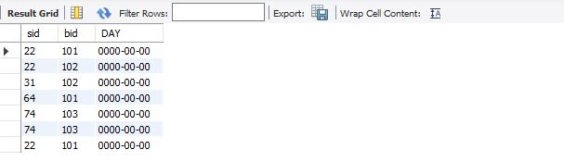

Update reserves set Day = '98/10/10' where bid=101;

Update reserves set Day = '98/10/10' where bid=102;

Update reserves set Day = '98/10/11' where bid=102;

Update reserves set Day = '98/5/9' where bid=101;

Update reserves set Day = '98/8/9' where bid=103;

Insert into boats values(101,'Interlake','blue');

Insert into boats values(102,'Interlake','red');

Insert into boats values(103,'Clipper','green');

Insert into boats values(104,'Marine','red');

Select * from boats;

4) Select sname,age from sailors;

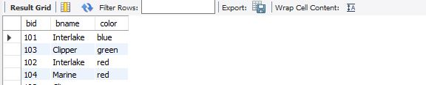

5) Select sid from sailors where rating>=8;

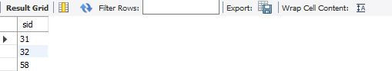

6) Select sname from sailors where rating > 7 union Select sname from sailors where age>25;

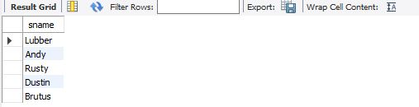

7) Select bname,color from boats;

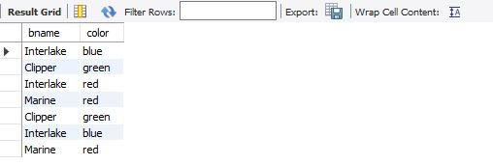

8) Select bname,bid from boats where color = 'red';

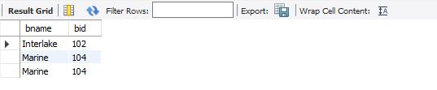

9) Select sname from sailors S,reserves R where S.sid=R.sid and bid = 101;



10) Select R.sid from boats B,reserves R where B.bid=R.bid and B.color = 'pink';



11) Select S.sname from sailors s,reserves R,boats B where S.sid = R.sid and R.bid=B.bid and B.color='red';

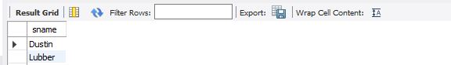

12) Select B.color from sailors S,boats B,reserves R where S.sid=R.sid and B.bid=R.bid and S.sname ='Lubber';



13) Select S.sname from sailors S,reserves R where S.sid=R.sid;

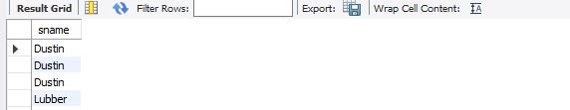

14) Select S.sname from sailors S,reserves R,boats B where S.sid = R.sid and R.bid=B.bid and B.color='red' union Select S.sname from sailors S,reserves R,boats B where S.sid = R.sid and R.bid=B.bid and B.color='green';

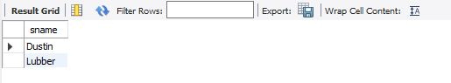

15) Select S.sname from sailors S,reserves R1,boats B1,reserves R2,boats B2 where S.sid=R1.sid and R1.bid=B1.bid and S.sid=R2.sid and R2.bid=B2.bid and (B1.color='red' and B2.color='green');

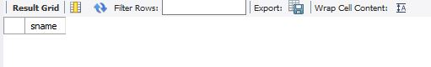

16) Select S.sname from sailors S where S.sid in(Select R.sid from reserves R where R.bid=3);

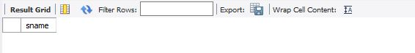

17) select S.sname from sailors S where S.sid in (select R.sid from reserves R where R.bid in (select B.bid from boats B where B.color='red'));

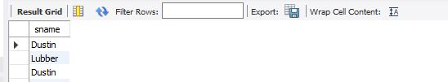

19) select S.sname from sailors S where S.sid not in (select R.sid from reserves R where R.bid not in (select B.bid from boats B where B.color='red'));

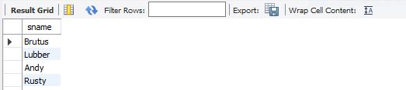

20) select S.sname from sailors S where exists (select * from reserves R where R.bid=103 and S.sid=R.sid);

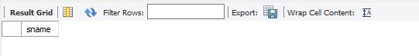

21) select * from sailors S where S.rating>any(select s2.rating from sailors s2 where s2.sname='Dustin');

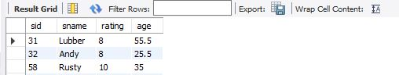

22) select * from sailors S where S.rating>=all(select s2.rating from sailors s2 where s2.sname='Dustin');

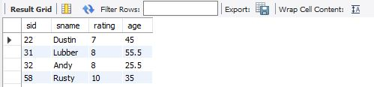

23) select * from sailors S where S.rating >=all(select s2.rating from sailors s2)

24) select avg(S.age) from sailors S;

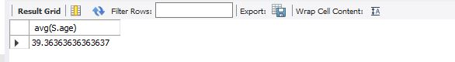

25) select avg(S.age) from sailors S where S.rating=10;

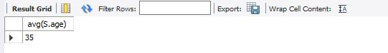

26) select count(*) from sailors S;

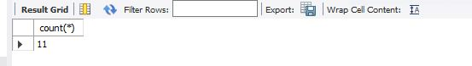

27) select count(distinct S.sname) from sailors S;

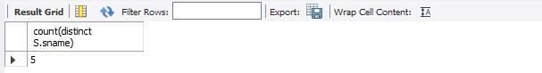

28) select S.sname, S.age from sailors S where (select max(S2.age) from sailors S2)=S.age;



29) select S.sname from sailors S where S.age> (select max(S2.age) from sailors S2 where S2.rating=10);

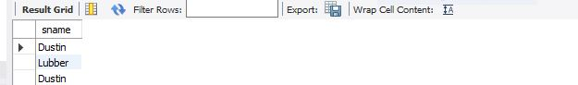

30) select S.rating,min(S.age) from sailors S group by S.rating;

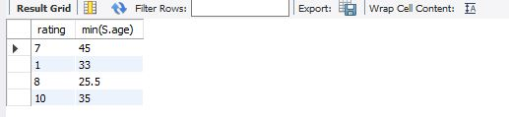

31) select S.rating,min(S.age) from sailors S where S.age>=18 group by S.rating having count(*)>1;

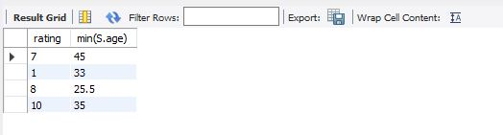

32) select B.bid,count(*) as reservationcount from boats B, reserves R where R.bid=B.bid and B.color='red' group by B.bid;

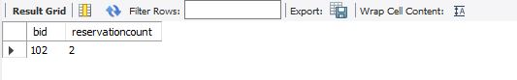

33) select S.sname from sailors S group by S.sname;

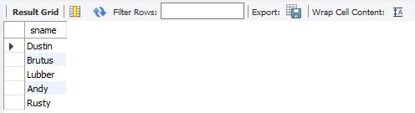

34) select S.sname from sailors S group by S.sname;

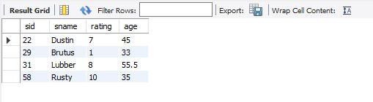

35) select * from sailors S order by rating desc,age asc;

